**Department of Computer Systems Engineering**

**University of Engineering and Technology**

**Peshawar, Pakistan**

**Communication Systems (MidTerm Exam), Fall 2020**

**Time Allowed: 02 Hours, Total Marks 150, Weightage: 20%**

* Attempt any 15 questions, ALL questions carry equal marks.
* Read the complete paper in the first 15 minutes and get your queries (if any) clarified within this time; No question will be entertained after this time. Moreover, if you feel any data missing, you can assume any reasonable values for it.

1. Differentiate analog and digital signals.
2. Briefly define the purpose of MODAM at transmitter and receiver.
3. How much signal power attenuated if its amplitude is 5V at the transmitter and the channel transfer function h = 0.8?
4. Differentiate attenuation and distortion.
5. What should be the sampling rate for the formation of the PCM signal?
6. What is quantization error? And how it can be minimized?
7. What effect occurs on data volume if quantization error reduces?
8. Find SNR at the output of the receiver if received signal power is 10 watts and noise is 0 Db.
9. What will be the offered capacity of a channel for GSM system? Use SNR value calculated from the above problem.
10. How BW related to the data rate? Calculate data rate for a GSM system.
11. Briefly describe the needs of modulation.
12. Find the power of the signal below.

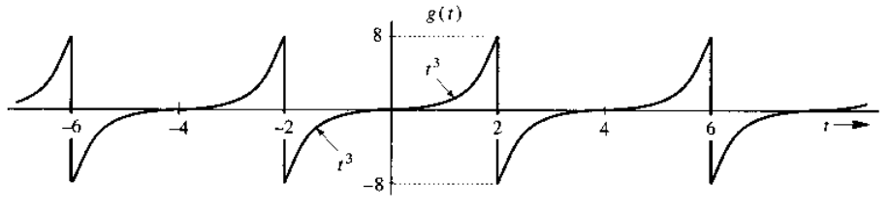

1. Draw x(0.5t – 0.5) and x(1.5t – 2.5) for a signal below.

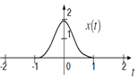

1. What are the properties of impulse function? How can we get the channel state information?
2. Sketch g(0.5t - 4), g(3t/1.5), g(2.5t - 8) and g(2 - t) for a figure given below.

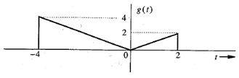

1. Describe how co-channel cells can be located in cellular systems if i = 2, and j = 1?